**Zone 1 - screenshots.**

**EC2 Instances**

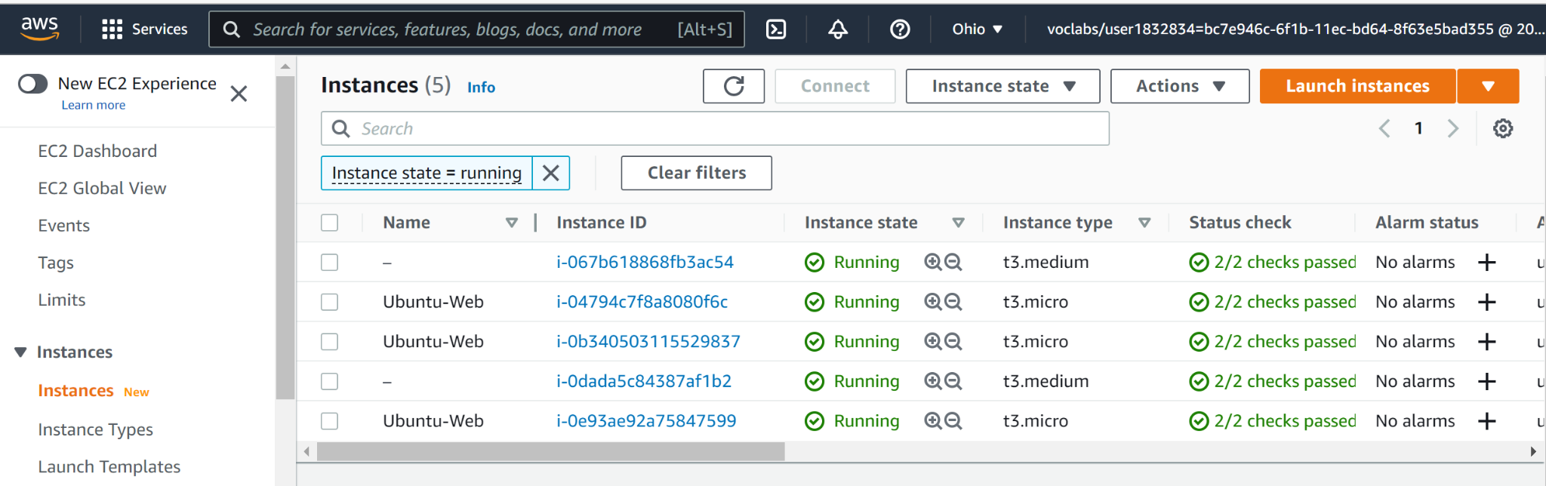

**Load balancers**

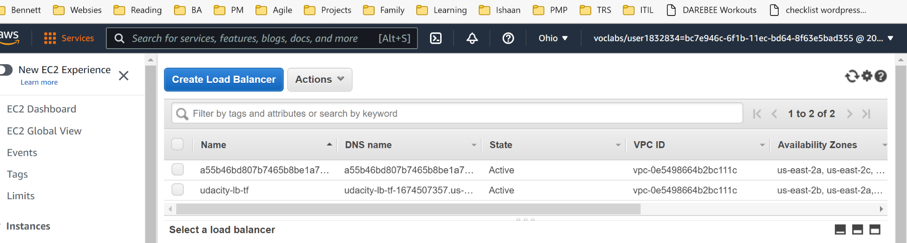

**EKS Clusters**

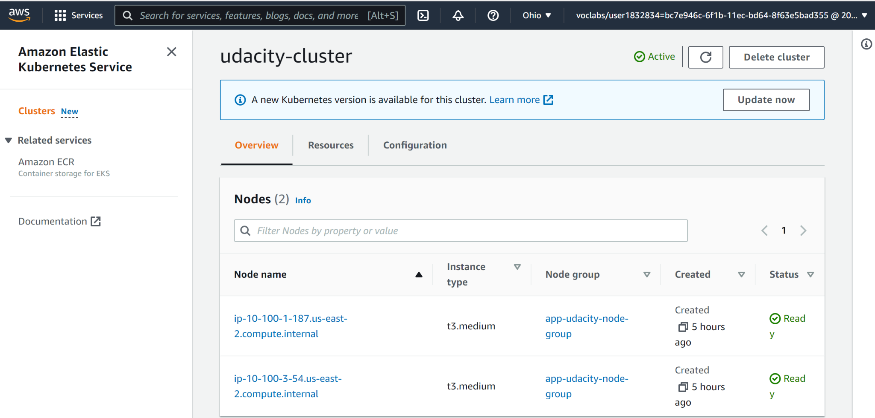

**RDS Instances**

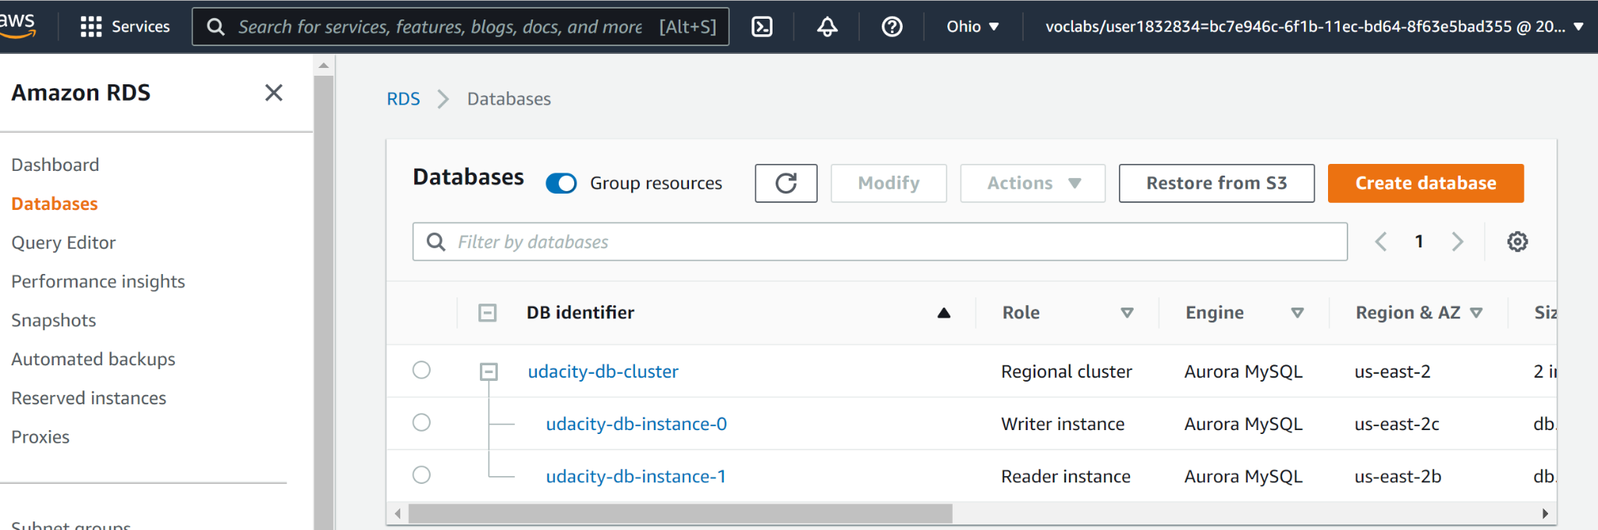

**VPC/Subnet**

